

26 September 2013

Dr. Jodi Rowley

Section Editor, Zootaxa

Dear Dr Rowley,

I would like to submit a manuscript titled “Integrative taxonomy uncovers a new species of upland Stream Toad of the genus *Ansonia* Stoliczka, 1870 (Anura: Bufonidae) from northeastern Peninsular Malaysia” for consideration and possible publication in *Zootaxa*.

The paper is straightforward and noncontroversial: morphological and genetic evidence suggest that the population of *Ansonia* from the northeastern state of Terengganu, Peninsular Malaysia represents a new species. This paper has not been published, is not currently being considered for publication elsewhere, and does not violate any copyright or other personal proprietary right of any person or entity and it contains no abusive, defamatory, obscene or fraudulent statements, nor any other statements that are unlawful  in any way.

I suggest Indraneil Das (hamadryad2004@hotmail.com), Bryan Stuart (bryan.stuart@naturalsciences.org), and Jeffery Wilkinson (jwilkinson@harveyecology.com) as reviewers, all of whom are well qualified to evaluate this paper.

Please do not hesitate to contact me if you have any questions and many thanks for your consideration.

Sincerely,

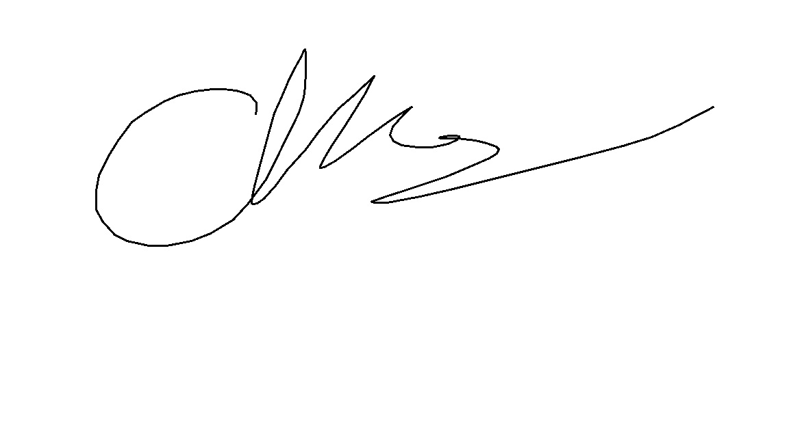

Kin Onn, Chan

University of Kansas

Dyche Hall, 1345 Jayhawk Blvd

Lawrence, KS 66045-7593

office: (785) 864-3403

Email: chanko@ku.edu